1. Create VPC
Go to VPC → Create VPC
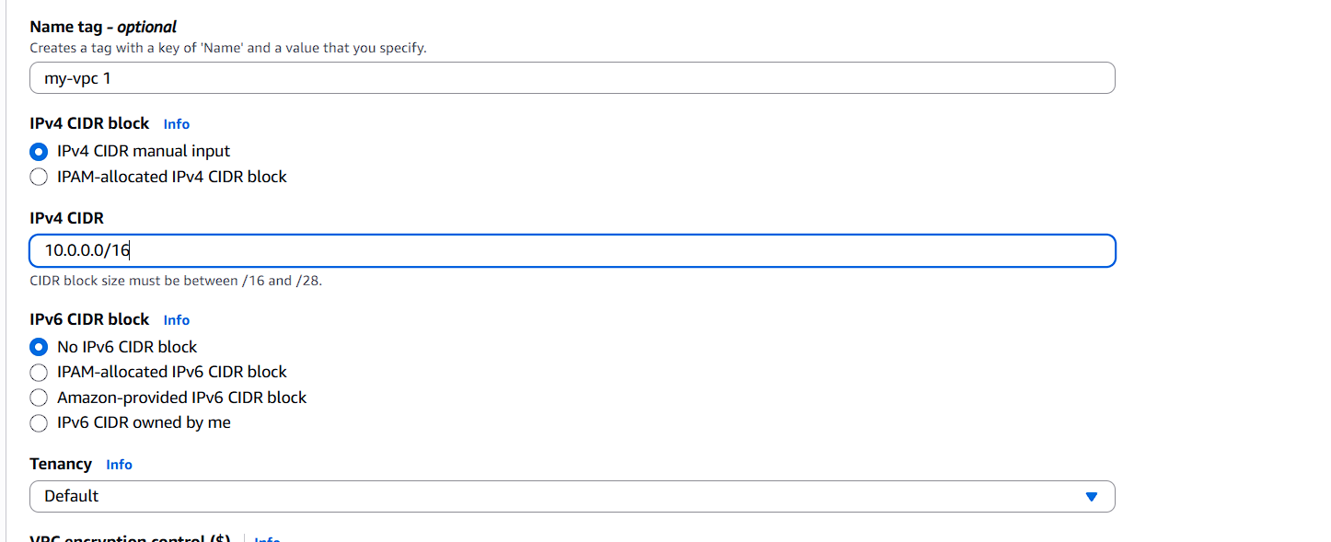

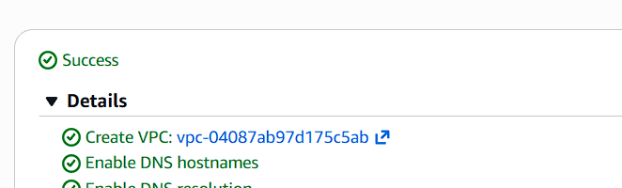

2. Create Subnets
Go to Subnets → Create Subnet
Public Subnet 1

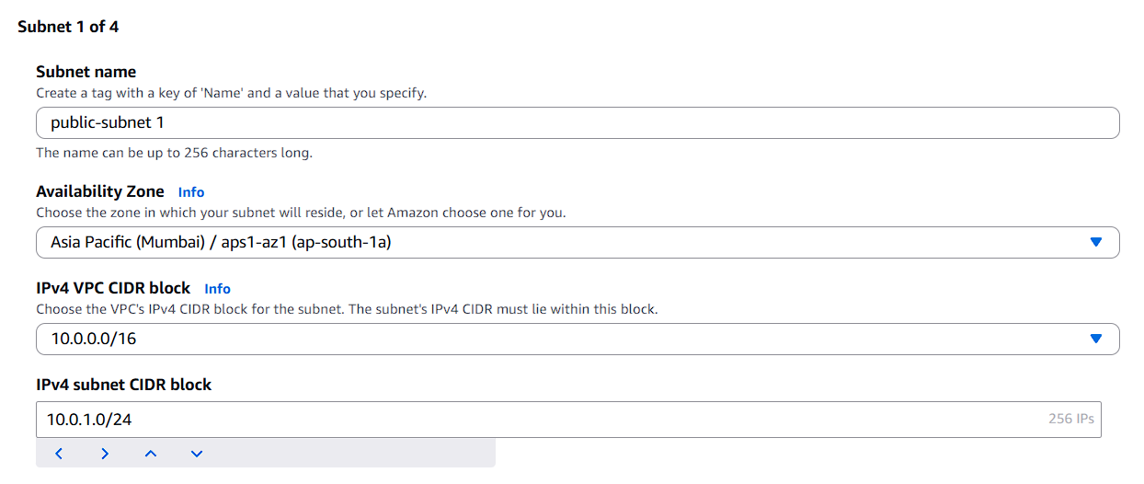

Auto Assign Public IP = Enable
Public Subnet 2
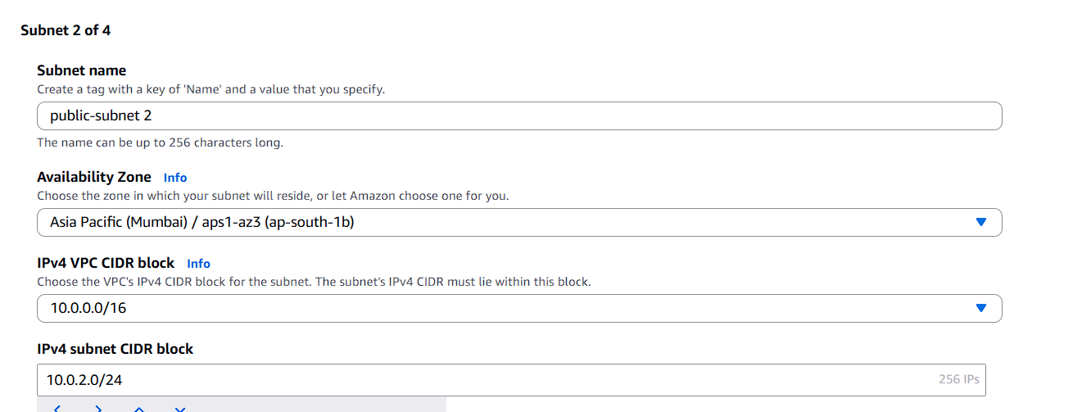
Auto Assign Public IP = Enable

Private Subnet 1

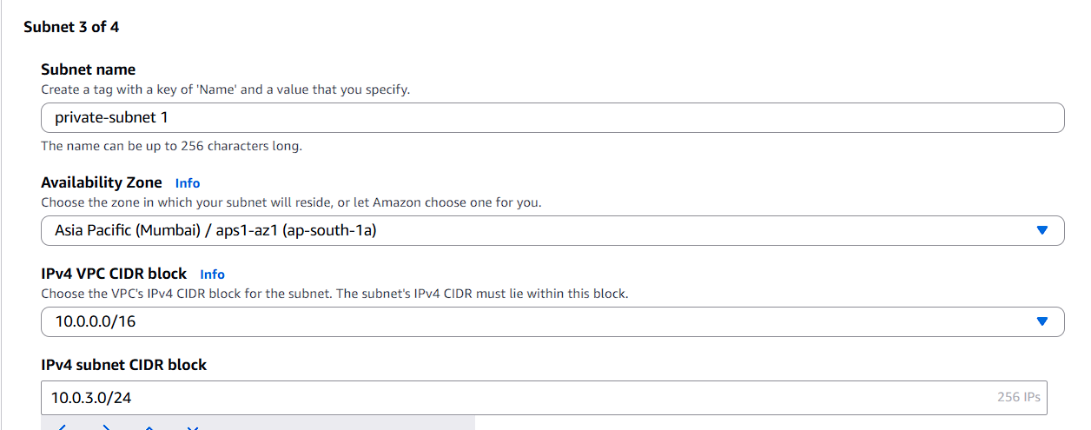

Private Subnet 2
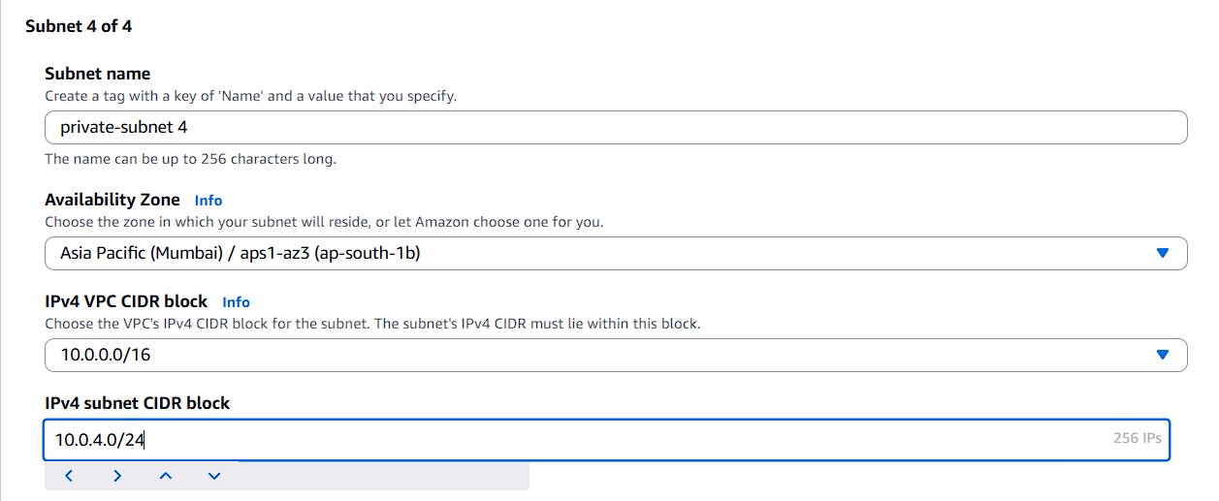
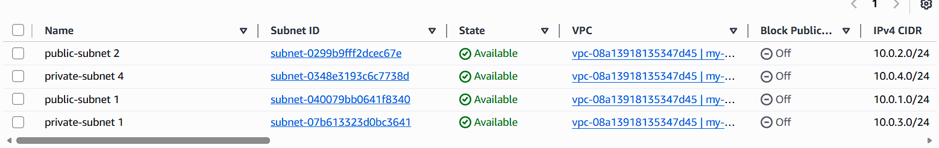

3. Create Internet Gateway
Go to Internet Gateway → Create
Attach it to student-vpc
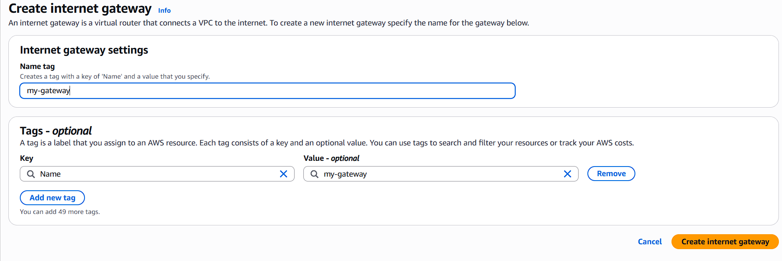
student-igw → Attach → student-vpc
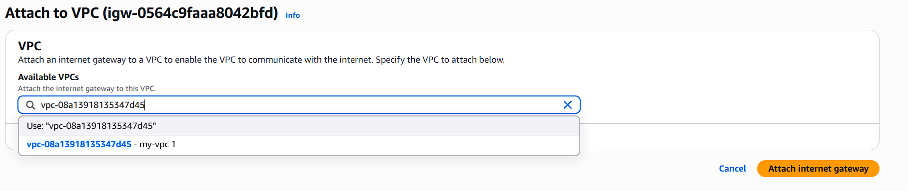

4. Create Public Route Table
Go to Route Tables → Create
Name
student-public-rt
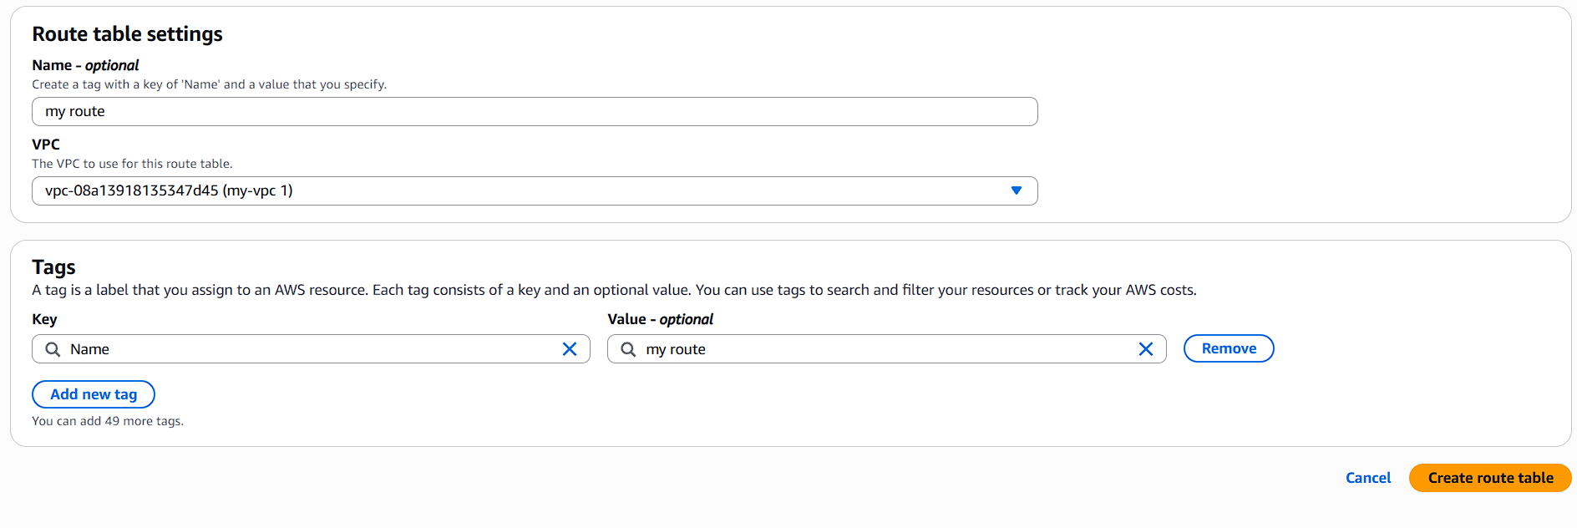
Attach to VPC: student-vpc

Add Route
Edit routes
Destination: 0.0.0.0/0
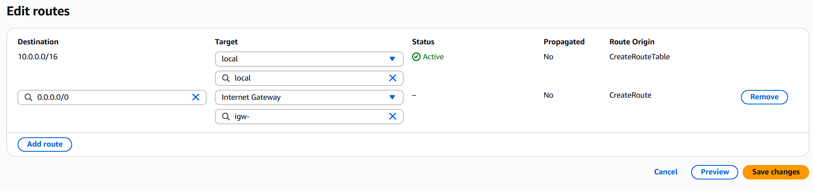
Target: student-igw
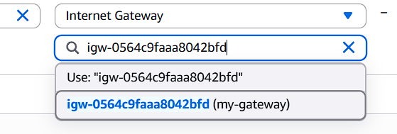

Attach Public Subnets
Subnet Associations:
Attach
student-public-subnet-1a
student-public-subnet-1b

5. Create Private Route Table

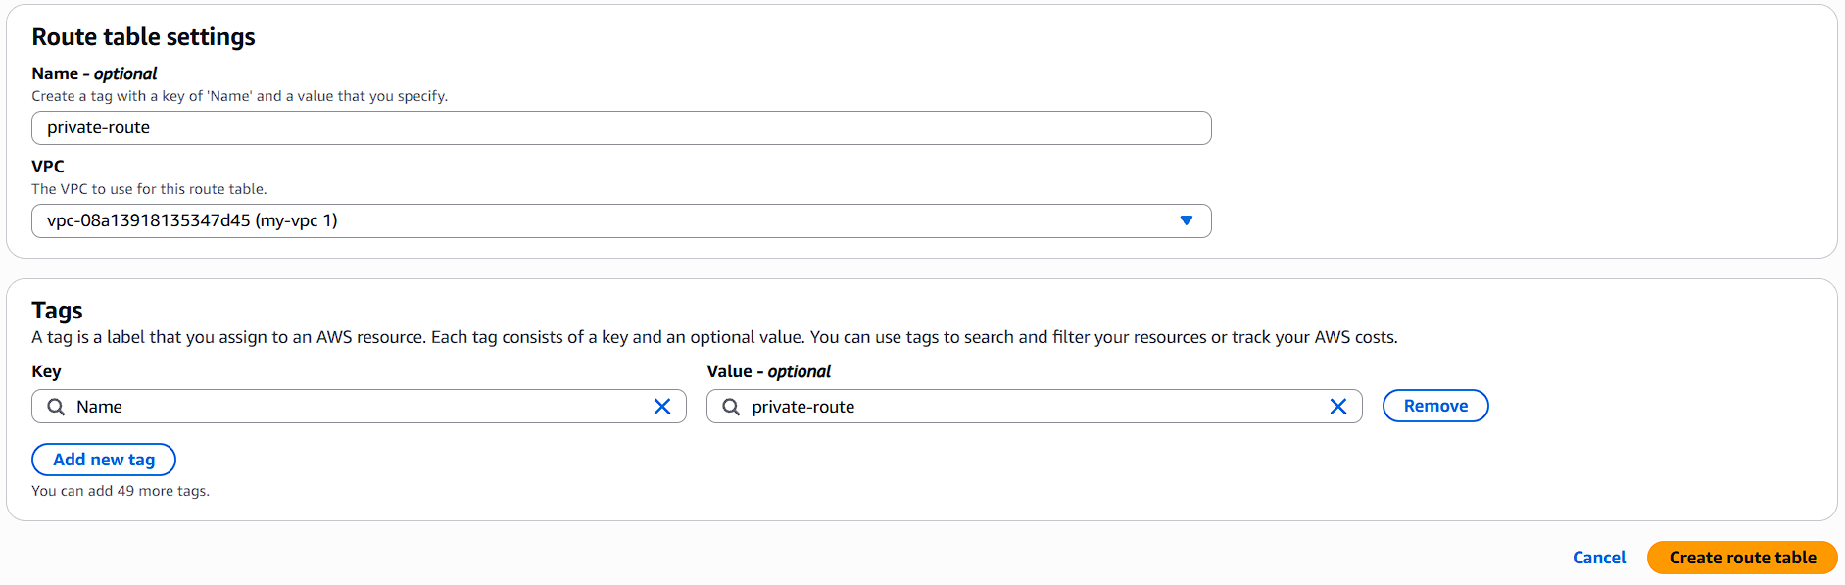

Attach Private Subnets
Associate
student-private-subnet-1a
student-private-subnet-1b
(No internet route)
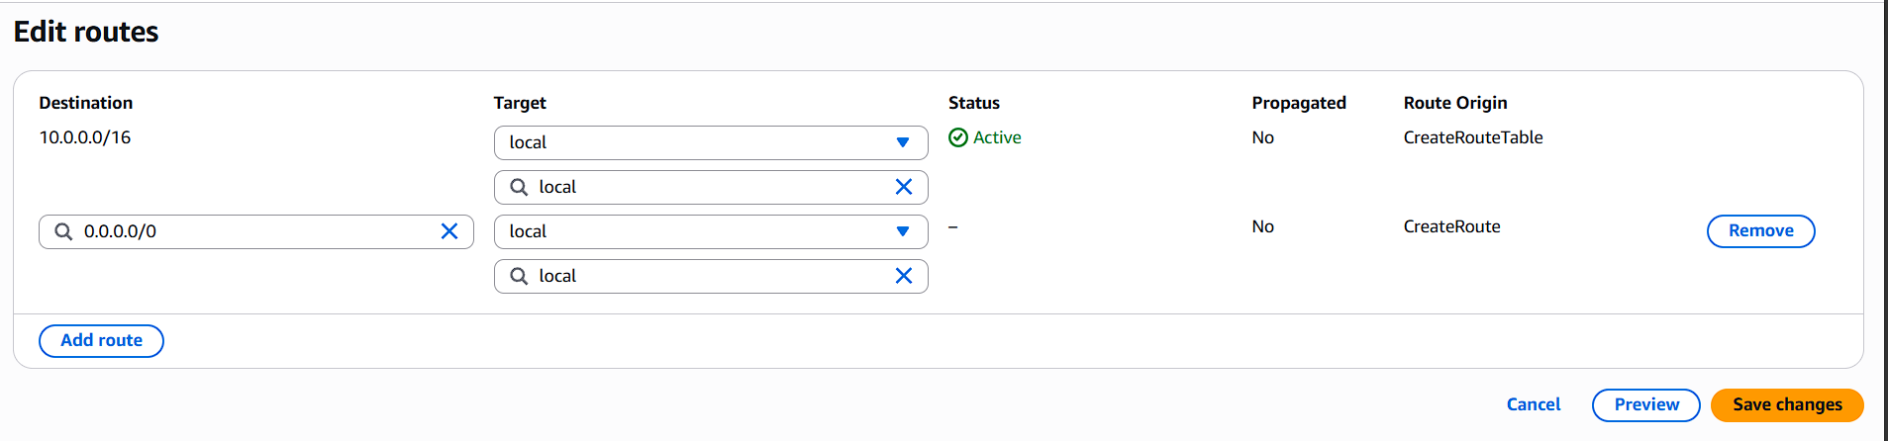
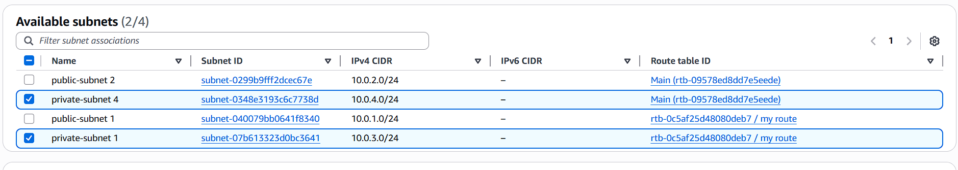

6. Create Security Group
Go to EC2 → Security Groups
Create
Inbound Rules
Type | Source
SSH | 0.0.0.0/0

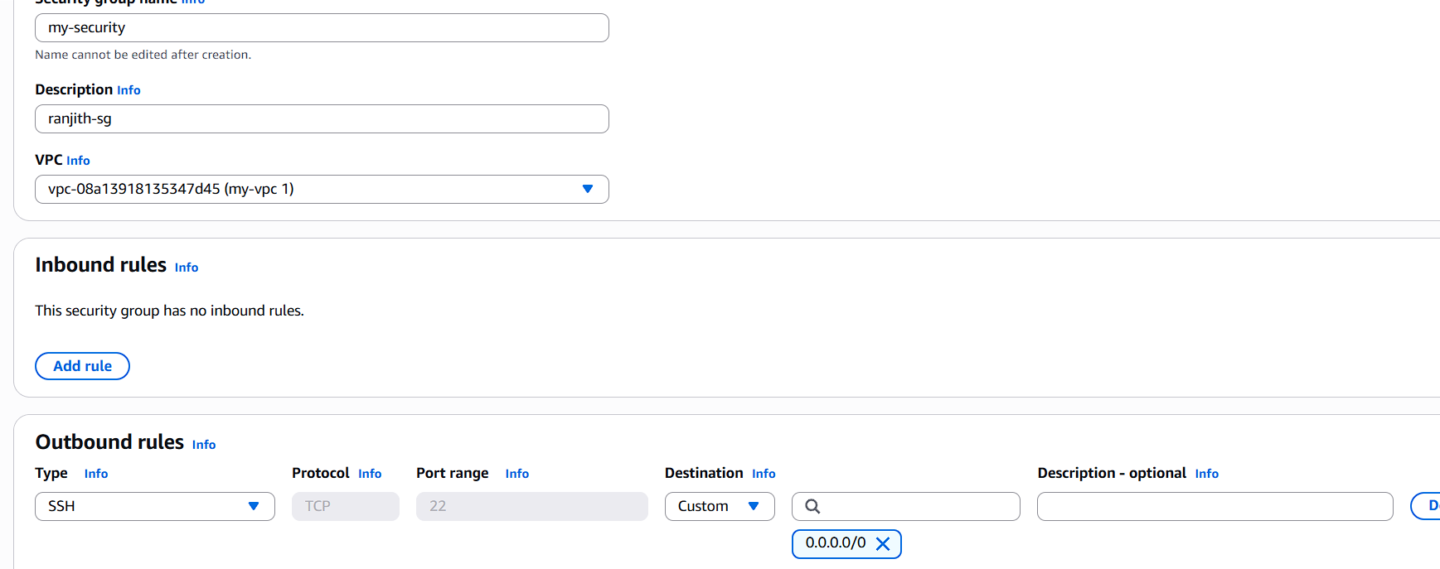
7. Launch Public EC2
Go to EC2 → Launch Instance
Launch
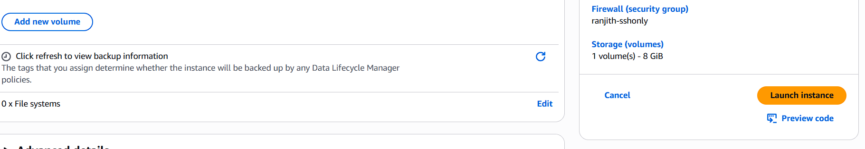
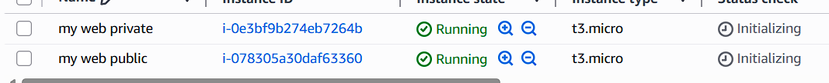

8. Launch Private EC2

9. Connect to Public EC2
SSH from your laptop
ssh -i student-key.pem ec2-user@PUBLIC-IP
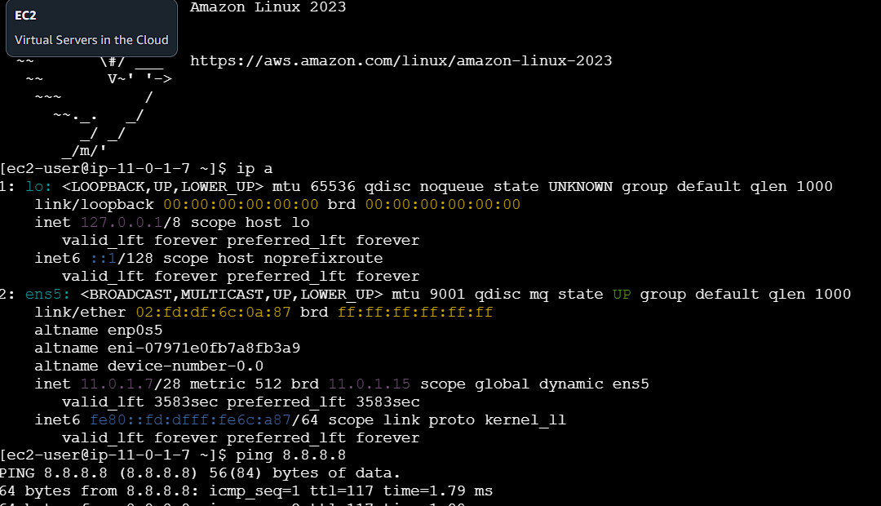

10. Test SSH to Private EC2
Inside public instance
Get private IP of private EC2.
Example:
10.0.3.10
Copy key
scp -i student-key.pem student-key.pem ec2-user@PUBLIC-IP:/home/ec2-user/
SSH
ssh -i student-key.pem ec2-user@10.0.3.10
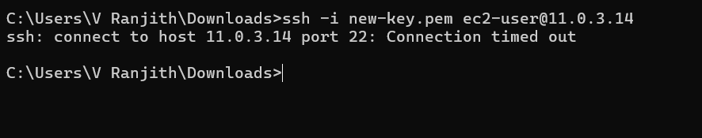

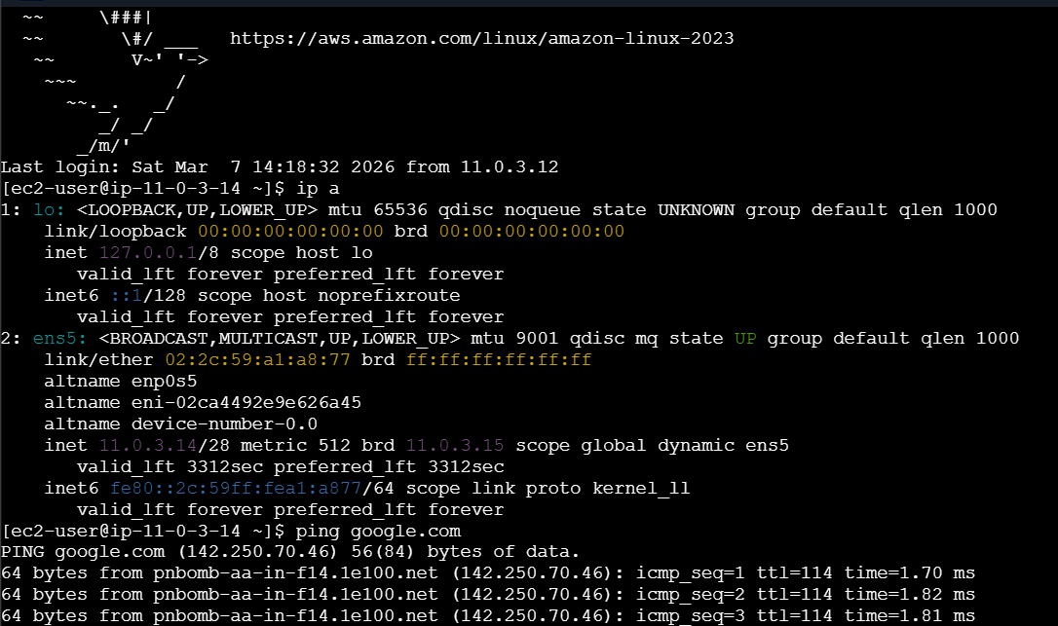

Expected Result
Architecture
Internet
|
Internet Gateway
|
student-vpc
|
------------------------------------
| |
Public Subnet Private Subnet
student-public-subnet-1a student-private-subnet-1a
| |
student-public-ec2 student-private-ec2
| |
-------- SSH Access ----------------
Public VM → SSH → Private VM

Validation Commands
On private VM
hostname
ip a
ping google.com
Expected
Ping should FAIL (no internet)
But
SSH from public should work

If you want, I can also give:
- Advanced VPC Lab (with NAT Gateway)
- 3 Tier Architecture Lab (Web + App + DB)
- 20 AWS VPC Interview Questions used in companies.

